**Electronic Circuits Spring 2021 Mid term Exam (Time Allowed: 2 Hrs)**

Please submit your answers with proper procedure on a separate sheet along with this sheet. Your answer should be rounded off to two decimal places. Each student is assigned a unique circuit value. Answers that do not correspond to the assigned values shall be considered wrong irrespective of the procedure.

**Name: Usman Yaqoob**

**Reg. No:19PWCSE1754**

Q1. Using the characteristics of Fig. 1a, determine ID, VD , and VR for the circuit of Fig. 1b. (For values of E and R refer to the table given at the end)

**Your Response:** (Marks: 5+5+5)

ID=_18.85mA

VD=1.3Volts 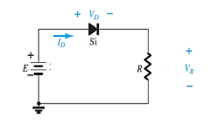

VR=8.7Volts

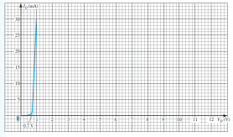

Figure 1a Figure 1b

**Procedure sheets are on next 2 pages..**

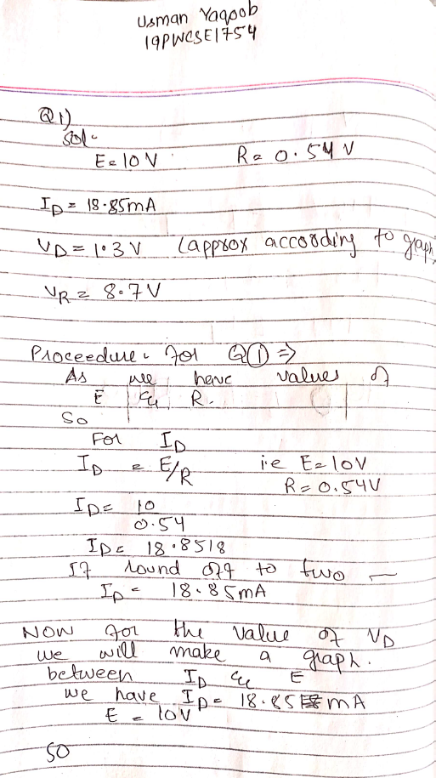

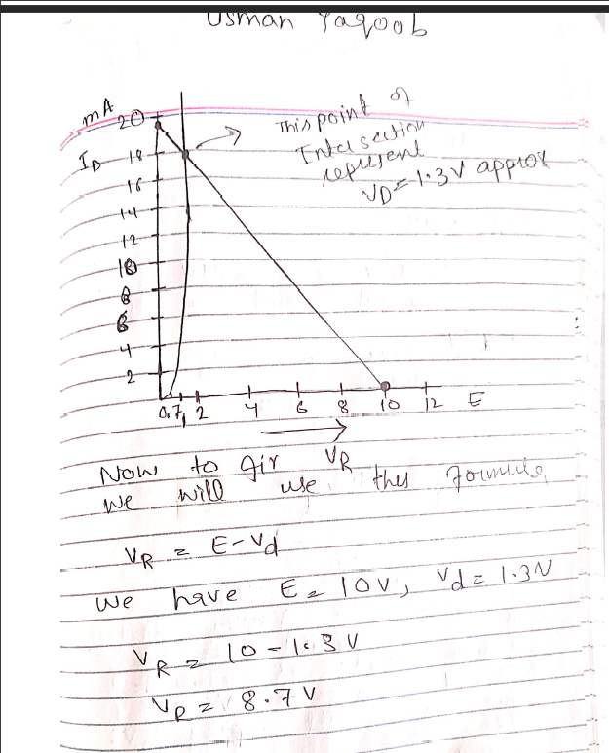

Q2. Determine *Vo* and *ID* for the networks of Fig. 2 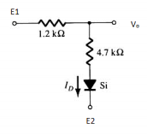

(For values of E1 and E2 refer to the table given at the end)

**Your Response:** (Marks: 5+5)

Vo =10.21Volts

Io =3.94mA

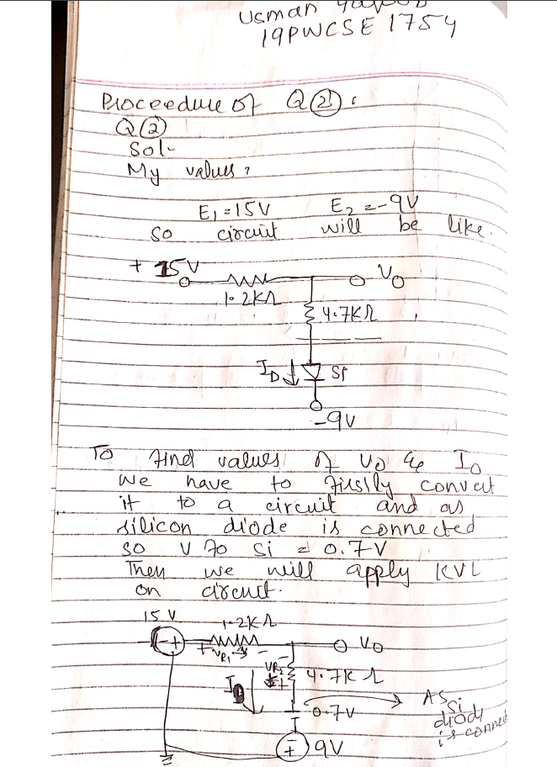

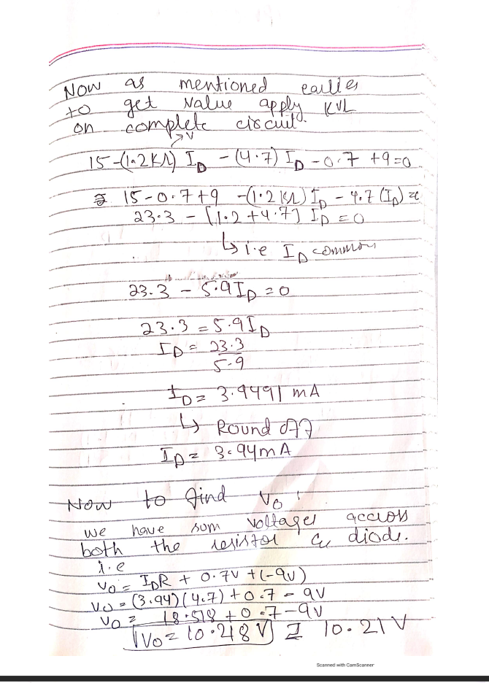

Q3. A full-wave bridge rectifier with a Vi (Volts) rms sinusoidal input has a load

resistor of R kΩ.

**a.** If silicon diodes are employed, what is the dc voltage available at the load?

**b.** Determine the minimum required PIV rating of each diode (considering Si diode).

**c.** Find the maximum current Im through each diode during conduction. (For values of E1 and E2 refer to the table given at the end)

Figure 2

**Your Response:** (Marks: 5+5+5)

VDC =109.73Volts

PIVmin =173.24mA

Im =383.24mA

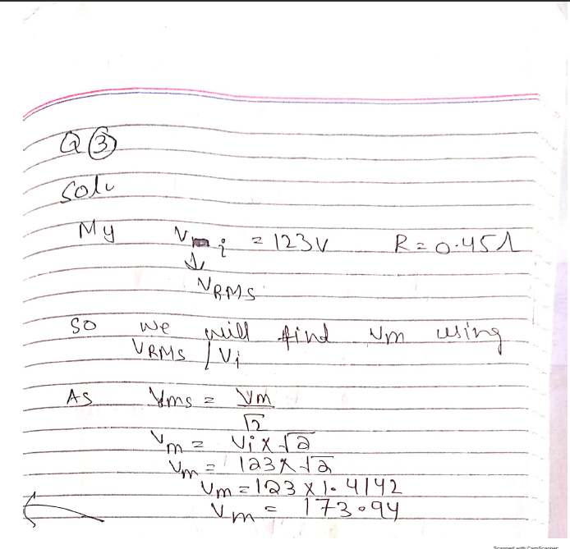

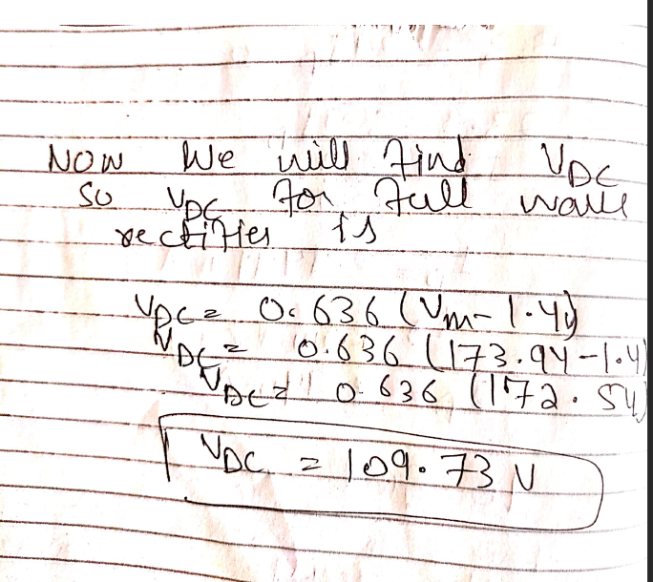

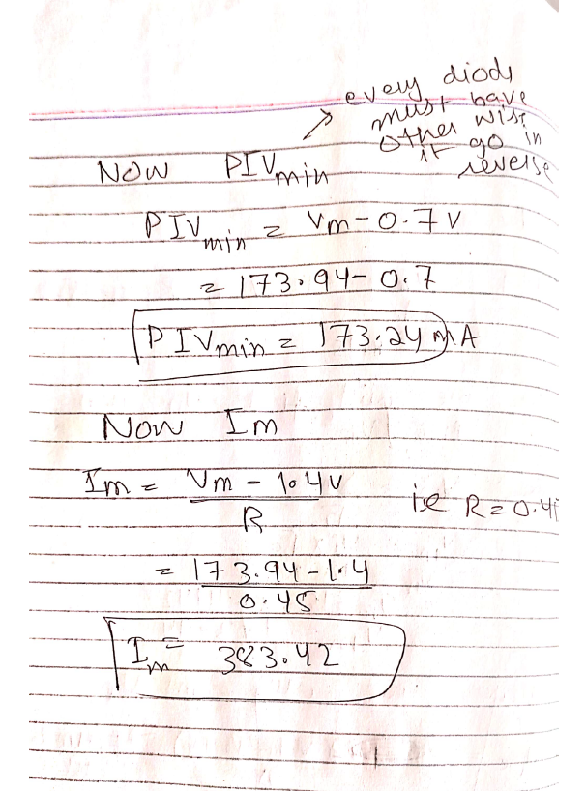

Q4. For the circuit shown in Fig 3, determine (a) Voltage across the capacitor VC, (b) Peak positive output Vo+, (c) Peak negative output Vo-.

(For values of Vm and E refer to the table given at the end) 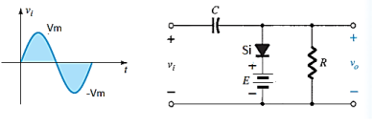Figure 3

**Your Response:** (Marks: 5+5+5)

VC =127.3Volts

Vo+ =19.7Volts

Vo- = -294Volts 🡪-2(Vm) for negative peak

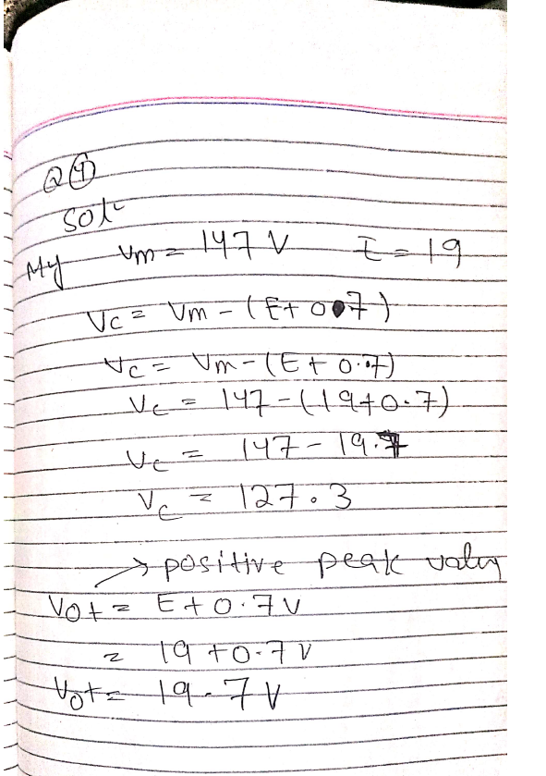

Q5. For the network of Figure 4, determine the range of Vi that will maintain VL at VZ Volts and not exceed the maximum power rating of the Zener diode.

(For values of Rs, VZ and RL refer to the table given at the end)

**Your Response:** (Marks: 5+5)

Vimin =________Volts Vimax =________Volts

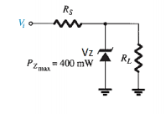



 Figure 4

**Appendix**

|  |  |  |  |  |  |  |  |  |  |  |  |  |
| --- | --- | --- | --- | --- | --- | --- | --- | --- | --- | --- | --- | --- |
| **Sr. No.** | **Registration #** | **Question1** | | **Question**  **2** | | **Question 3** | | **Question**  **4** | | **Question 5** | | |
|  |  | **)**  **s**    **t**  **l**  **E**  **o**  **V**  **(** | **)**  **s**    **m**  **h**  **R**  **O**    **k**  **(** | **s**    **t**  **l**  **1**  **o**  **E**  **V** | **2**  **E** | **)**  **s**  **s**  **t**  **m**  **l**  **r**  **o**  **(**    **i**  **V**  **V** | **)**  **s**    **m**  **h**  **R**  **O**    **k**  **(** | **m**  **V** | **E** | **s**  **m**  **h**  **O**  **s**  **R** | **s**  **t**  **l**  **o**  **V**    **Z**  **V** | **s**  **m**  **h**  **O**    **L**  **R** |
| 1 | 19PWCSE1741 | **7** | **1.84** | **5** | **-10** | **193** | **0.47** | **146** | **14** | **93** | **10** | **1080** |
| 2 | 19PWCSE1743 | **6** | **1.63** | **13** | **-5** | **115** | **0.43** | **166** | **9** | **141** | **10** | **710** |
| 3 | 19PWCSE1745 | **10** | **1.81** | **12** | **-5** | **162** | **0.32** | **137** | **11** | **137** | **12** | **230** |
| 4 | 19PWCSE1747 | **11** | **1.91** | **7** | **-9** | **157** | **1.11** | **148** | **20** | **133** | **7** | **390** |
| 5 | 19PWCSE1749 | **10** | **0.97** | **6** | **-7** | **160** | **1.08** | **198** | **13** | **106** | **9** | **740** |
| 6 | 19PWCSE1750 | **9** | **0.66** | **14** | **-9** | **110** | **1.55** | **114** | **19** | **112** | **14** | **820** |
| 7 | 19PWCSE1752 | **6** | **1.62** | **9** | **-9** | **134** | **1.89** | **181** | **8** | **130** | **13** | **1150** |
| 8 | 19PWCSE1753 | **7** | **0.54** | **8** | **-7** | **200** | **1.07** | **146** | **8** | **133** | **14** | **450** |
| 9 | 19PWCSE1755 | **11** | **0.84** | **7** | **-8** | **177** | **1.1** | **175** | **18** | **99** | **13** | **990** |
| 10 | 19PWCSE1757 | **8** | **1.66** | **14** | **-8** | **196** | **1.23** | **104** | **13** | **122** | **14** | **960** |
| 11 | 19PWCSE1759 | **8** | **1.07** | **8** | **-10** | **171** | **0.34** | **164** | **10** | **104** | **12** | **770** |
| 12 | 19PWCSE1761 | **7** | **0.43** | **10** | **-5** | **176** | **1.75** | **122** | **10** | **118** | **15** | **420** |
| 13 | 19PWCSE1763 | **5** | **1.65** | **13** | **-9** | **149** | **0.82** | **144** | **12** | **143** | **13** | **890** |
| 14 | 19PWCSE1765 | **7** | **1.03** | **14** | **-5** | **127** | **0.87** | **115** | **10** | **102** | **13** | **1120** |
| 15 | 19PWCSE1767 | **12** | **1.01** | **11** | **-9** | **127** | **0.89** | **173** | **9** | **115** | **12** | **1050** |
| 16 | 19PWCSE1770 | **6** | **0.23** | **14** | **-8** | **159** | **1.17** | **109** | **14** | **108** | **14** | **1150** |
| 17 | 19PWCSE1772 | **12** | **0.98** | **12** | **-5** | **129** | **0.42** | **105** | **10** | **150** | **8** | **440** |
| 18 | 19PWCSE1774 | **12** | **0.71** | **10** | **-6** | **161** | **0.67** | **178** | **11** | **121** | **7** | **360** |
| 19 | 19PWCSE1776 | **8** | **1.98** | **10** | **-8** | **192** | **0.55** | **109** | **9** | **145** | **14** | **740** |
| 20 | 19PWCSE1778 | **7** | **1.37** | **14** | **-7** | **163** | **0.82** | **146** | **19** | **113** | **7** | **560** |
| 21 | 19PWCSE1781 | **10** | **0.68** | **9** | **-7** | **197** | **1.06** | **118** | **16** | **128** | **9** | **1090** |
| 22 | 19PWCSE1783 | **5** | **1.01** | **13** | **-6** | **126** | **0.61** | **176** | **6** | **101** | **15** | **800** |
| 23 | 19PWCSE1786 | **9** | **1.54** | **7** | **-9** | **191** | **1.54** | **157** | **18** | **129** | **11** | **810** |
| 24 | 19PWCSE1788 | **7** | **1.46** | **13** | **-5** | **198** | **1.53** | **196** | **15** | **135** | **11** | **340** |
| 25 | 19PWCSE1790 | **9** | **0.98** | **5** | **-7** | **139** | **2** | **161** | **11** | **128** | **8** | **880** |
| 26 | 19PWCSE1792 | **11** | **1.69** | **10** | **-10** | **132** | **0.5** | **105** | **11** | **142** | **7** | **1180** |
| 27 | 19PWCSE1794 | **6** | **1.76** | **12** | **-6** | **119** | **1.83** | **122** | **6** | **130** | **10** | **400** |
| 28 | 19PWCSE1796 | **5** | **1.3** | **11** | **-8** | **156** | **0.25** | **192** | **14** | **139** | **12** | **290** |
| 29 | 19PWCSE1797 | **5** | **1.66** | **6** | **-8** | **186** | **1.91** | **140** | **5** | **120** | **11** | **360** |
| 30 | 19PWCSE1799 | **6** | **1.07** | **15** | **-6** | **166** | **0.6** | **184** | **11** | **137** | **9** | **800** |
| 31 | 19PWCSE1801 | **8** | **0.58** | **10** | **-10** | **105** | **1.53** | **187** | **16** | **99** | **9** | **1080** |
| 32 | 19PWCSE1802 | **9** | **0.86** | **7** | **-9** | **191** | **1.2** | **137** | **9** | **130** | **9** | **680** |
| 33 | 19PWCSE1804 | **11** | **0.16** | **6** | **-10** | **164** | **0.13** | **129** | **16** | **145** | **11** | **970** |
| 34 | 19PWCSE1806 | **6** | **0.94** | **10** | **-10** | **158** | **1.23** | **189** | **9** | **143** | **9** | **1200** |

35 19PWCSE1807 **10 0.3 15 -6 200 0.22 143 11 138 13 590**

|  |  |  |  |  |  |  |  |  |  |  |  |  |
| --- | --- | --- | --- | --- | --- | --- | --- | --- | --- | --- | --- | --- |
| 36 | 19PWCSE1809 | **9** | **0.52** | **6** | **-7** | **102** | **0.79** | **149** | **19** | **149** | **10** | **910** |
| 37 | 19PWCSE1811 | **8** | **0.69** | **15** | **-6** | **170** | **1.56** | **133** | **15** | **91** | **7** | **930** |
| 38 | 19PWCSE1812 | **5** | **0.28** | **5** | **-9** | **122** | **1.69** | **158** | **12** | **121** | **14** | **450** |
| 39 | 19PWCSE1814 | **8** | **1.44** | **10** | **-8** | **163** | **0.26** | **163** | **5** | **146** | **7** | **1070** |
| 40 | 19PWCSE1740 | **9** | **0.58** | **8** | **-10** | **127** | **0.22** | **168** | **18** | **130** | **11** | **660** |
| 41 | 19PWCSE1742 | **11** | **1.63** | **7** | **-8** | **110** | **1.01** | **132** | **10** | **106** | **14** | **460** |
| 42 | 19PWCSE1744 | **8** | **0.55** | **9** | **-10** | **169** | **1.92** | **168** | **18** | **92** | **11** | **1110** |
| 43 | 19PWCSE1746 | **7** | **0.39** | **14** | **-9** | **111** | **0.4** | **104** | **18** | **128** | **12** | **710** |
| 44 | 19PWCSE1748 | **6** | **0.71** | **15** | **-8** | **159** | **0.65** | **194** | **12** | **103** | **13** | **480** |
| 45 | 19PWCSE1751 | **7** | **0.41** | **14** | **-8** | **163** | **0.72** | **198** | **7** | **103** | **12** | **640** |
| 46 | 19PWCSE1754 | **10** | **0.54** | **15** | **-9** | **123** | **0.45** | **147** | **19** | **140** | **7** | **840** |
| 47 | 19PWCSE1756 | **12** | **1.78** | **5** | **-10** | **156** | **0.89** | **174** | **19** | **138** | **7** | **1130** |
| 48 | 19PWCSE1758 | **5** | **0.86** | **12** | **-6** | **187** | **0.38** | **135** | **18** | **115** | **15** | **900** |
| 49 | 19PWCSE1760 | **11** | **1.58** | **6** | **-8** | **131** | **0.9** | **139** | **13** | **130** | **11** | **520** |
| 50 | 19PWCSE1762 | **5** | **1.99** | **13** | **-9** | **116** | **1.19** | **153** | **20** | **91** | **15** | **510** |
| 51 | 19PWCSE1764 | **10** | **1.66** | **10** | **-8** | **188** | **0.93** | **187** | **11** | **137** | **9** | **1100** |
| 52 | 19PWCSE1766 | **7** | **1.45** | **9** | **-6** | **124** | **1.95** | **189** | **7** | **138** | **9** | **470** |
| 53 | 19PWCSE1768 | **7** | **0.51** | **14** | **-9** | **154** | **0.66** | **144** | **7** | **139** | **12** | **460** |
| 54 | 19PWCSE1769 | **9** | **1.76** | **6** | **-5** | **121** | **1.02** | **133** | **20** | **110** | **10** | **660** |
| 55 | 19PWCSE1771 | **10** | **1.76** | **6** | **-9** | **143** | **1.79** | **140** | **15** | **95** | **11** | **850** |
| 56 | 19PWCSE1773 | **8** | **1.16** | **8** | **-7** | **196** | **0.89** | **167** | **7** | **111** | **8** | **500** |
| 57 | 19PWCSE1775 | **9** | **1.29** | **8** | **-9** | **173** | **0.11** | **107** | **13** | **148** | **9** | **410** |
| 58 | 19PWCSE1777 | **11** | **0.7** | **13** | **-8** | **192** | **0.68** | **158** | **6** | **132** | **15** | **650** |
| 59 | 19PWCSE1779 | **10** | **0.41** | **6** | **-10** | **145** | **1.6** | **138** | **18** | **130** | **12** | **1080** |
| 60 | 19PWCSE1780 | **5** | **1.56** | **6** | **-8** | **175** | **1.27** | **136** | **18** | **134** | **13** | **750** |
| 61 | 19PWCSE1782 | **10** | **1.94** | **8** | **-8** | **173** | **0.77** | **159** | **7** | **137** | **15** | **560** |
| 62 | 19PWCSE1784 | **10** | **1.91** | **13** | **-5** | **150** | **0.99** | **120** | **7** | **147** | **11** | **680** |
| 63 | 19PWCSE1785 | **8** | **1.78** | **15** | **-5** | **139** | **0.75** | **169** | **20** | **101** | **7** | **440** |
| 64 | 19PWCSE1787 | **11** | **1.3** | **13** | **-6** | **145** | **0.31** | **142** | **19** | **148** | **9** | **870** |
| 65 | 19PWCSE1789 | **10** | **1.58** | **8** | **-10** | **194** | **1.23** | **134** | **17** | **126** | **11** | **350** |
| 66 | 19PWCSE1791 | **6** | **1.2** | **7** | **-5** | **167** | **0.93** | **100** | **15** | **132** | **13** | **580** |
| 67 | 19PWCSE1793 | **7** | **0.6** | **6** | **-9** | **141** | **0.11** | **177** | **5** | **98** | **12** | **610** |
| 68 | 19PWCSE1795 | **7** | **1.54** | **15** | **-9** | **111** | **1.64** | **143** | **6** | **99** | **14** | **280** |
| 69 | 19PWCSE1798 | **7** | **0.48** | **7** | **-10** | **140** | **1.22** | **166** | **5** | **92** | **9** | **890** |
| 70 | 19PWCSE1800 | **8** | **1.79** | **6** | **-7** | **100** | **0.49** | **106** | **15** | **130** | **15** | **540** |
| 71 | 19PWCSE1803 | **12** | **1.51** | **8** | **-9** | **183** | **1.24** | **133** | **7** | **142** | **7** | **640** |
| 72 | 19PWCSE1805 | **7** | **0.52** | **11** | **-10** | **200** | **0.06** | **173** | **13** | **97** | **11** | **640** |
| 73 | 19PWCSE1808 | **8** | **1.3** | **9** | **-9** | **199** | **0.2** | **135** | **11** | **107** | **12** | **1200** |
| 74 | 19PWCSE1810 | **12** | **0.52** | **13** | **-6** | **138** | **1.92** | **162** | **9** | **132** | **9** | **850** |
| 75 | 19PWCSE1813 | **6** | **0.55** | **10** | **-10** | **198** | **1.5** | **172** | **16** | **97** | **9** | **260** |

76 19PWCSE1815 **6 0.19 8 -7 150 0.74 133 13 143 10 1110**

|  |  |  |  |  |  |  |  |  |  |  |  |  |
| --- | --- | --- | --- | --- | --- | --- | --- | --- | --- | --- | --- | --- |
| 77 | 19PWCSE1816 | **5** | **0.27** | **10** | **-8** | **100** | **1.3** | **165** | **10** | **145** | **9** | **330** |
| 78 | 19PWCSE1858 | **12** | **1.58** | **13** | **-10** | **197** | **1.6** | **115** | **11** | **149** | **11** | **1130** |
| 79 | 18PWCSE1716 | **5** | **0.9** | **13** | **-8** | **198** | **1.97** | **190** | **7** | **101** | **13** | **560** |
| 80 | 19PWCSE1818 | **8** | **1.43** | **11** | **-6** | **190** | **1.41** | **200** | **5** | **112** | **11** | **650** |
| 81 | 19PWCSE1819 | **8** | **0.33** | **6** | **-5** | **103** | **1** | **197** | **14** | **127** | **8** | **740** |
| 82 | 19PWCSE1820 | **5** | **1.05** | **14** | **-8** | **134** | **1.32** | **151** | **7** | **149** | **15** | **690** |
| 83 | 19PWCSE1821 | **12** | **1.63** | **6** | **-6** | **180** | **0.22** | **112** | **9** | **91** | **8** | **940** |
| 84 | 19PWCSE1822 | **7** | **1.07** | **13** | **-9** | **100** | **1.98** | **103** | **19** | **93** | **10** | **1140** |
| 85 | 19PWCSE1823 | **10** | **1.72** | **7** | **-8** | **164** | **0.68** | **182** | **17** | **148** | **11** | **980** |
| 86 | 19PWCSE1824 | **11** | **0.44** | **14** | **-5** | **133** | **1.67** | **121** | **20** | **90** | **14** | **210** |
| 87 | 19PWCSE1825 | **11** | **1.02** | **15** | **-7** | **181** | **0.34** | **195** | **18** | **108** | **15** | **820** |
| 88 | 19PWCSE1826 | **12** | **0.72** | **13** | **-9** | **132** | **1.43** | **171** | **16** | **102** | **13** | **370** |
| 89 | 19PWCSE1827 | **11** | **1.41** | **12** | **-9** | **153** | **0.53** | **111** | **10** | **115** | **12** | **940** |
| 90 | 19PWCSE1828 | **6** | **0.88** | **11** | **-5** | **141** | **1.15** | **196** | **15** | **111** | **7** | **570** |
| 91 | 19PWCSE1829 | **8** | **0.65** | **10** | **-6** | **115** | **1.23** | **199** | **11** | **90** | **11** | **870** |
| 92 | 19PWCSE1830 | **11** | **1.32** | **10** | **-9** | **153** | **0.37** | **196** | **15** | **124** | **15** | **340** |
| 93 | 19PWCSE1831 | **6** | **1.82** | **13** | **-9** | **182** | **1.88** | **167** | **17** | **96** | **7** | **380** |
| 94 | 19PWCSE1832 | **12** | **1** | **14** | **-5** | **143** | **1.58** | **185** | **11** | **145** | **10** | **980** |
| 95 | 19PWCSE1833 | **5** | **1.2** | **7** | **-7** | **196** | **0.9** | **192** | **20** | **120** | **15** | **520** |
| 96 | 19PWCSE1834 | **6** | **1.99** | **13** | **-7** | **171** | **1.31** | **172** | **6** | **114** | **9** | **710** |
| 97 | 19PWCSE1835 | **5** | **0.17** | **6** | **-8** | **108** | **1.75** | **194** | **19** | **94** | **13** | **480** |
| 98 | 19PWCSE1836 | **6** | **0.18** | **7** | **-10** | **163** | **0.63** | **191** | **5** | **123** | **14** | **470** |
| 99 | 19PWCSE1837 | **10** | **0.54** | **15** | **-6** | **129** | **1** | **163** | **19** | **140** | **14** | **570** |
| 100 | 19PWCSE1838 | **6** | **0.61** | **5** | **-7** | **199** | **0.84** | **137** | **7** | **102** | **7** | **870** |
| 101 | 19PWCSE1839 | **8** | **1.54** | **14** | **-9** | **161** | **1.32** | **178** | **9** | **90** | **8** | **600** |
| 102 | 19PWCSE1840 | **11** | **0.93** | **15** | **-5** | **189** | **0.32** | **184** | **18** | **101** | **10** | **350** |
| 103 | 19PWCSE1841 | **5** | **1.63** | **5** | **-10** | **169** | **0.97** | **175** | **13** | **119** | **9** | **270** |
| 104 | 19PWCSE1842 | **6** | **0.84** | **5** | **-9** | **104** | **0.27** | **172** | **8** | **99** | **10** | **380** |
| 105 | 19PWCSE1843 | **7** | **0.61** | **14** | **-6** | **139** | **1.93** | **109** | **14** | **128** | **15** | **320** |
| 106 | 19PWCSE1844 | **7** | **1.6** | **12** | **-6** | **167** | **2** | **163** | **10** | **140** | **9** | **750** |
| 107 | 19PWCSE1845 | **10** | **0.16** | **15** | **-5** | **149** | **0.17** | **131** | **14** | **136** | **8** | **390** |
| 108 | 19PWCSE1846 | **11** | **0.62** | **5** | **-10** | **157** | **1.05** | **183** | **6** | **110** | **14** | **1080** |
| 109 | 19PWCSE1847 | **9** | **1.18** | **15** | **-6** | **141** | **0.22** | **118** | **16** | **140** | **11** | **300** |
| 110 | 19PWCSE1848 | **5** | **0.43** | **5** | **-9** | **155** | **0.19** | **124** | **10** | **146** | **13** | **590** |
| 111 | 19PWCSE1849 | **11** | **0.39** | **6** | **-9** | **116** | **1.94** | **123** | **5** | **150** | **15** | **440** |
| 112 | 19PWCSE1850 | **7** | **0.37** | **6** | **-8** | **200** | **1.31** | **176** | **5** | **109** | **11** | **510** |
| 113 | 19PWCSE1851 | **9** | **0.41** | **5** | **-9** | **173** | **1.49** | **121** | **10** | **141** | **8** | **710** |
| 114 | 19PWCSE1852 | **6** | **0.58** | **11** | **-5** | **147** | **0.85** | **166** | **19** | **96** | **9** | **940** |
| 115 | 19PWCSE1853 | **11** | **0.53** | **10** | **-8** | **145** | **1.78** | **194** | **16** | **124** | **11** | **210** |
| 116 | 19PWCSE1854 | **12** | **1.34** | **12** | **-6** | **139** | **0.68** | **194** | **6** | **122** | **13** | **1040** |

117 19PWCSE1855**6 0.81 10-6 111 1.1 1269 114 15 710**

|  |  |  |  |  |  |  |  |  |  |  |  |  |
| --- | --- | --- | --- | --- | --- | --- | --- | --- | --- | --- | --- | --- |
| 118 | 19PWCSE1856 | **6** | **0.57** | **6** | **-9** | **107** | **0.89** | **136** | **9** | **121** | **10** | **880** |
| 119 | 19PWCSE1857 | **6** | **1.6** | **12** | **-6** | **160** | **1.84** | **194** | **17** | **90** | **12** | **650** |
| 120 | 15pwcse1368 | **12** | **1.84** | **9** | **-9** | **100** | **0.97** | **172** | **18** | **112** | **14** | **490** |
| 121 | 16pwcse1450 | **11** | **1.63** | **8** | **-5** | **164** | **0.27** | **105** | **8** | **93** | **7** | **750** |
| 122 | 15pwcse1366 | **6** | **1.81** | **7** | **-10** | **133** | **1.93** | **189** | **5** | **127** | **10** | **400** |
| 123 | 17pwcse1603 | **8** | **1.91** | **14** | **-9** | **181** | **2** | **122** | **7** | **149** | **7** | **950** |
| 124 | 16pwcse1465 | **11** | **0.97** | **8** | **-6** | **132** | **0.17** | **143** | **20** | **121** | **11** | **610** |
| 125 | 16pwcse1477 | **6** | **0.66** | **10** | **-6** | **153** | **1.05** | **132** | **19** | **141** | **7** | **350** |
| 126 | 17pwcse1575 | **12** | **1.62** | **13** | **-5** | **141** | **0.22** | **114** | **13** | **120** | **12** | **250** |
| 127 | 17pwcse1602 | **5** | **0.54** | **14** | **-10** | **115** | **0.19** | **185** | **8** | **124** | **8** | **620** |
| 128 | 17pwcse1554 | **6** | **0.84** | **11** | **-6** | **153** | **1.94** | **171** | **11** | **101** | **7** | **1020** |
| 129 | 16pwcse1496 | **5** | **1.66** | **14** | **-9** | **182** | **1.31** | **158** | **8** | **129** | **7** | **290** |
| 130 | 17pwcse1587 | **6** | **1.07** | **12** | **-9** | **143** | **1.49** | **116** | **5** | **118** | **8** | **590** |
| 131 | 17pwcse1500 | **10** | **0.43** | **10** | **-8** | **196** | **0.85** | **187** | **20** | **91** | **13** | **440** |
| 132 | 16pwcse1490 | **6** | **1.65** | **10** | **-9** | **171** | **1.78** | **117** | **18** | **102** | **8** | **320** |
| 133 | 17pwcse1516 | **8** | **1.03** | **14** | **-5** | **108** | **0.68** | **141** | **13** | **102** | **10** | **580** |